Project Proposal
Project Title: | Student Sentiment Analysis in social media: A Monitoring Tool for Student Satisfaction

Student Name | : | Lim Yong Kang
Matric Number | : | 279868
Supervisor | : | Dr Mohamad Sabri Bin Sinal@Zainal

INTRODUCTION
In this era of technology, social media has become an essential part of our lives. It helps us to find the latest trends, news, and information about anything we want. Social media also has a vital role in education. It can help teachers and students share their opinions and experiences in education. Universities have used different social media platforms, such as Facebook and Twitter, to promote their facilities and services and give announcements to students.

To better understand students’ needs from social media, a university can collect information from the posts and comments by students. However, Due to the wide range and popularity of social media, many user comments or opinions are generated and shared by students daily. This situation will lead to the process of gathering information from students being more challenging than expected.

One approach to overcoming these issues is to use sentiment analysis. Sentiment analysis is a way to measure the attitude of people toward a brand, product, or service. It is based on natural language processing (NLP) and machine learning, which helps to extract opinions from raw data like text posts. Sentiment analysis can identify and extract the emotional content in customer opinions to become significant business value, which is the basis of decision-making (Baj-Rogowska,2017). So, this study will help the management authority of each department in UUM to create a "UUM Student Satisfaction Analysis Monitoring Tool" to analyze the UUM student’s opinions about UUM’s services on social media.

This study is very important because sentiment analysis is a tool for managing each department to understand the students' satisfaction with the school services quickly. Therefore, students' opinions and ideas are indispensable. Determining student satisfaction with the school through sentiment analysis of formal and informal terms raises the attention of the management of each department. It allows the best solution to be found. This enables the administration of each department to be ahead of the competition of the university administration. To effectively observe student satisfaction, the administration of each department monitors the current service situation for one semester and makes changes.

Although this sentiment analysis monitoring was developed for the administrative authority of UUM departments, the administrative authority of other universities can also be consulted or utilized to help them understand student evaluations of university services and make the best decisions in the shortest time with the least number of resources.

- UUM | PREVIOUS WORK  The study mentions a sentiment analysis for evaluating universities In German. It was highlighted how sentiment analysis might help university rankings that come under criticism for evaluating essential metrics. They collected and extracted feedback and reaction on the daily event or activities on Twitter. Then based on the data, the keyword will be filtered and extracted. The keyword will be positively or negatively classified by supervised learning classifiers and the Natural language Tool Kit in Python. The classifier performance by using naïve bayes are 73.6% success. The accuracy is relatively low to prove a statement. So, this project not only uses Naïve Bayes learning to calculate the accuracy of the statement. (Abdelrazeq et al., 2016)  The study (Umair et al., 2021) discusses the sentiment analysis of students’ feedback before and after the Covid-19 pandemic. This study will compare the sentiment class of the student’s feedback and find the difference between the written and expressed sentiments of the students. They use Text blob and Vader to detect the textual data; then, the detected data will be extracted by Bag of word and TF-IDF. After detecting and extracting the textual data, these data will be classified by the machine learning approach of supervised learning: Naïve Bayes and SVM.  An article (Menaha et al., 2017) studies the development of a student feedback mining system which can apply and analyze the sentiment of the text from the students’ feedback. This study aims to provide instructors with qualitative feedback to improve the student’s learning. In this project, stop-word removal is used to fit out the irrelevant word in the text. Next is the clustering process to partition the data set into groups based on similar groups and assign it to each group. Then, the clustered data is classified as either positive or negative by the algorithm. The weakness of this project is that the irrelevant word is not entirely removed from the text, which will lead to the accuracy of the analysis being wrong. In order to prevent this problem, in addition to stopping word removal, other irrelevant words (such as overlapping words) or emoticons will also be removed.  The paper (Baj-Rogowska, 2017) discusses the sentiment Analysis of the Uber case on the Facebook case. This study aims to reveal changes in how Uber is viewed by its users and demonstrate how sentiment analysis can accurately capture customer sentiment and effectively deliver appealing and creative offers. They proposed the paper by the lexicon-based study to categorise the text as positive, negative, or neutral.

PROBLEM STATEMENT
Nowadays, universities offer different methods to collect students' opinions. For example, some universities offer voting methods or provide questionnaires. These methods list questions or statements about an area, and students can only answer yes or no, or rate from one to ten. While universities can improve with feedback from polls and questionnaires, some current issues still need to be addressed. This situation will result in a significant waste of time and resources when evaluating universities.

The main reason is that students can only answer the statements in the polls and questionnaires provided. They cannot openly share their views about the services provided by the university. For this reason, the student will voice their opinions about the services provided by universities on social media. They use social media to share their true feelings without thinking of any limitations or obstacles. Although universities also use social media, they use it more to promote the university and give announcements. Universities can use social media to observe students' opinions and sentiments about the services of every department in universities. However, with the popularity of social media, students are sharing posts and comments about universities daily. This situation makes it difficult for universities to collect information, and it is time-consuming to analyse these sentences. UUM is facing the same problem. So, they needed a system to collect, analyse and map the data.

The Sentiment Analysis Monitoring Tool can help solve these problems. The Sentiment Analysis Monitoring Tool is a tool that identifies and classifies the attitudes expressed in texts and then monitors and manages them. For example, it identifies the author's posts to determine whether the author's attitude is positive, negative or neutral. (Rodriguez et al., 2019) This situation will help universities get the maximum number of keywords and comments in the shortest time to identify the issues they need to pay attention to improve the system's quality.
However, UUM still needs to get a monitoring tool to analyze students' social media posts. This sentiment analysis monitoring is crucial for UUM. Therefore, the researcher recommends the creation of a "UUM Student Satisfaction Analysis Monitoring Tool" as the main platform for students and the university to monitor and change the quality of the university.

OBJECTIVES
- To determine the most sentences of a positive and negative sentiment of the key or particular words about UUM students’ opinions.
- To identify key or particular words about UUM students' opinions on social media.
- To construct a suitable model for sentiment analysis monitoring tools based on observation
- To develop a sentiment analysis monitoring tool to analyse and monitor social media content.
- To classify and validate the positive and negative sentiment of the key or particular words about UUM students’ opinions.

PROJECT SCOPE
The scope of the research will be:

- "UUM Student Satisfaction Analysis Monitoring Tool" will be developed for the management authority of each department in UUM to analyze and visualize the collected data from social media.
- The data sources will be from a social media group, which is N.E.W.S.E.E.D. on Facebook.
- The post by students is chosen to focus on this project. Posts like announcements or advertisements will be eliminated.
- The posts written in languages other than English, such as Malay, Mandarin, and Tamil are removed.
- The positive and negative sentiments of the key or particular words about UUM students' opinions will visualize on the monitoring tool
PROJECT SIGNIFICANCE
This "UUM Student Satisfaction Analysis Monitoring Tool" offers some contributions.
1. The sentiment analysis process enables stakeholders to quickly collect, extract, analyze, and present actual data results, alleviating the resources and time required to gather information.
2. Second, it helps stakeholders understand the analysis results and implement the necessary solutions to help students solve real-life problems. For example, suppose they want to know how students live in the dormitory. In this case, they can enter and search for posts about the student environment and then extract and analyse those posts to decide whether to improve or maintain the status.
3. Third, the stakeholders have the opportunity to understand and learn how to use sentiment analysis to improve their knowledge in managing the university.
4. Finally, it also helps to change the perception of people (not only teachers, students, and staff) about the university in terms of management.

METHODOLOGY
For the methodology, Waterfall Development (Winston w. Royce,1970) will be selected to develop the "UUM Student Satisfaction Analysis Monitoring Tool". Waterfall Development is the linear approach to complete each phase before moving to the next phase. Waterfall Development in this project includes 5 phases: planning, analysis, design, implementation, and testing.

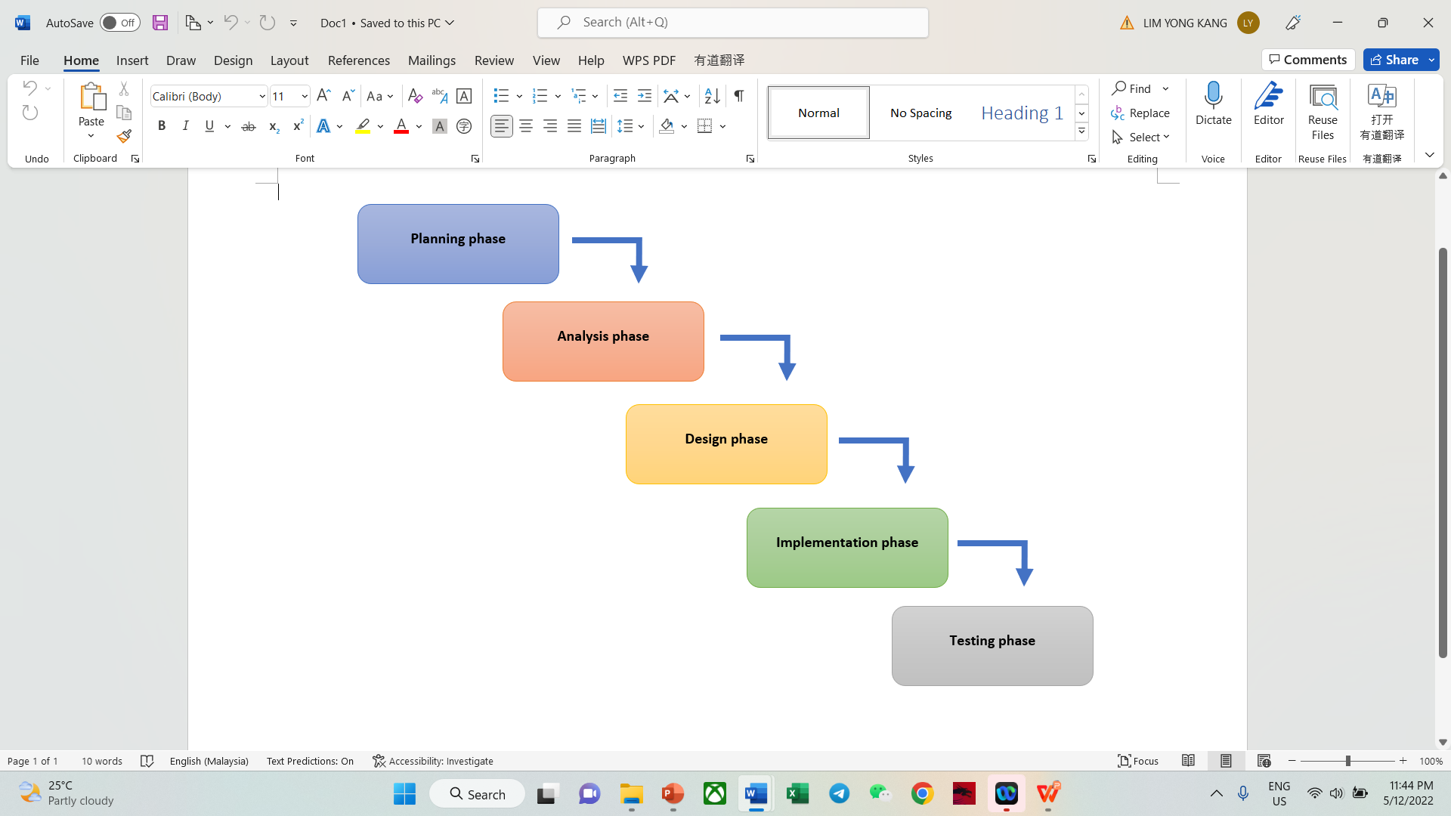

Planning phase
In this phase, the topic of the project will be selected. The next step is discussing the requirement of the project with the supervisor. This project requires to development sentiment analysis monitoring tool to help the management authority of each department to analyse and visualize the collected data from social media. The project proposal will start production after discussing the requirement of the project. The proposal will include the project introduction, previous work, problem statement, objective, scope, methodology, and project schedule (Gantt chart).

Requirement Analysis Phase
In this phase, the collected information and requirements will be analysed to determine whether these requirements are functional or non-functional. The functional requirement is the process that the system must do. In contrast, the non-functional requirement is the process of how well the system performs, such as usability, security, and performance. After analysing the requirements, it will be documented in the list of requirements. Then, the use case diagrams, activity diagrams and class diagrams can be designed to understand the system’s flow.

Design Phase
A structural diagram of the monitoring tool's system will be presented in this phase. Low-fidelity prototypes and high-fidelity prototypes will be used to design the monitoring tools. The low-fidelity prototype will structure the core functionality of the monitoring administration, the information architecture, and the flow between pages. The high-fidelity prototype will present the final look of the monitoring administration.

Implementation Phase
In this phase, the monitoring tool will be produced and perform the expected functionality to ensure it can function as planned. This monitoring will include the programming language Python, and MySQL will be used as a database to keep all the project's data.

Testing Phase
This phase will be the project evaluation part when the project has been completed. The completed monitoring tool will be tested to ensure it can work properly. "UUM Student Satisfaction Analysis Monitoring Tool" will be evaluated by the management authority of each department in UUM to ensure the objective and scope are fulfilled.

8.0 | PROJECT SCHEDULE
 | Project 1

ACTIVITY | Duration Day | Start | End | Final Year Project 1
WEEK |  |  |  | 1 | 2 | 3 | 4 | 5 | 6 | 7 | 8 | 9 | 10 | 11 | 12 | 13 | 14
Select the topic of the project | 7 | 1/11/2022 | 7/11/2022
Prepare the project proposal | 7 | 8/11/2022 | 14/11/2022
Submit and present draft proposal | 1 | 15/11/2022 | 15/11/2022
Correction of the proposal | 21 | 15/11/2022 | 5/12/2022
Submit and present project proposal | 1 | 6/12/2022 | 6/12/2022
Prepare Requirement Analysis | 20 | 7/12/2022 | 26/12/2022
Presentation of requirement analysis | 1 | 27/12/2022 | 27/12/2022
Prepare low fidelity report and demo | 27 | 28/12/2022 | 23/1/2023
Submit and present low fidelity | 1 | 24/1/2023 | 24/1/2023

Project 2

ACTIVITY | Duration Day | Start | End | Final Year Project 2
WEEK |  |  |  | 1 | 2 | 3 | 4 | 5 | 6 | 7 | 8 | 9 | 10 | 11 | 12 | 13 | 14
Prepare high-fidelity report and demo | 30 | 2/4/2023 | 2/5/2023
Submit and present high-fidelity report and demo | 1 | 3/5/2023 | 3/5/2023
Project implementing ,testing &evaluation | 40 | 4/5/2023 | 9/6/2023
Prepare Final report | 30 | 13/6/2023 | 13/7/2023
Present Final Report | 1 | 14/7/2022 | 14/7/2023

REFERENCES

Abdelrazeq, A., Janßen, D., Tummel, C., Jeschke, S., & Richert, A. (2016). Sentiment Analysis of Social Media for Evaluating Universities. Automation, Communication and Cybernetics in Science and Engineering 2015/2016, 233–251. https://doi.org/10.1007/978-3-319-42620-4_19
Baj-Rogowska, A. (2017). Sentiment analysis of Facebook posts: The Uber case. 2017 Eighth International Conference on Intelligent Computing and Information Systems (ICICIS). https://doi.org/10.1109/intelcis.2017.8260068
Menaha, R., Dhanaranjani, R., Rajalakshmi, T., & Yogarubini, R. (2017). Student Feedback Mining System Using Sentiment Analysis. International Journal of Computer Applications Technology and Research, 6(1), 51–55. https://doi.org/10.7753/ijcatr0601.1009
Rodriguez, A., Argueta, C., & Chen, Y. L. (2019). Automatic Detection of Hate Speech on Facebook Using Sentiment and Emotion Analysis. 2019 International Conference on Artificial Intelligence in Information and Communication (ICAIIC). https://doi.org/10.1109/icaiic.2019.8669073
Umair, M., Hakim, A., Hussain, A. and Naseem, S. (2021). Sentiment Analysis of

Students’ Feedback before and after COVID-19 Pandemic. International Journal on

Emerging Technologies, 12(2): 177–182.

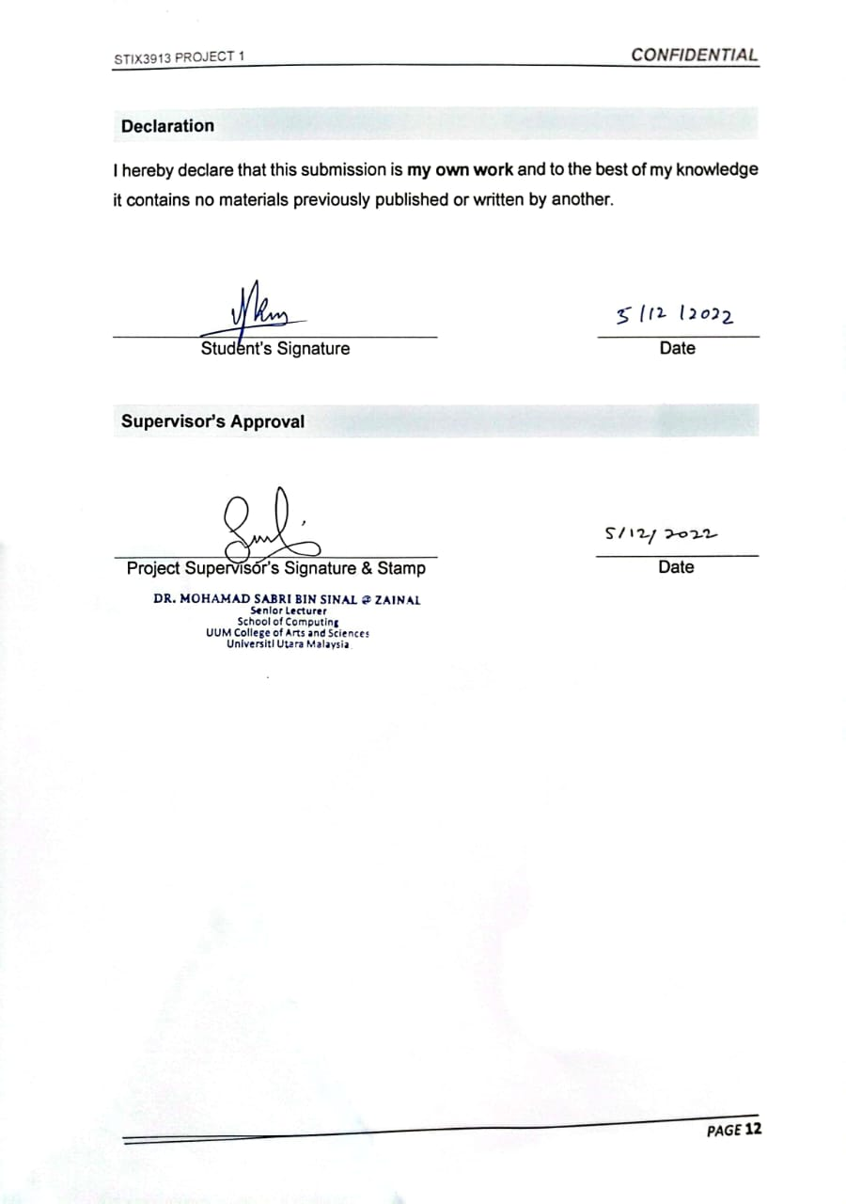

Lecturer’s Approval

Approve without modification
Approve with modification
Reject

Remark:
___________________________________________________________________
___________________________________________________________________
___________________________________________________________________
___________________________________________________________________

Lecturer’s Signature & Stamp |  | Date

